Technical University of Cluj-Napoca
Automation and Computer Science Faculty
Automation and Applied Informatics

Student : Kerekes Emeric-Andras | Coordinator:
Group: 30321 | Assist. Eng. Iulia STEFAN
2016-2017

Summary

Contents
Drafting 1 2
Drafting 2 4
OpenGL 6
LISP 9

Drafting 1
The main command used: pline, chamfer, mirror, filet, dimlinear, arc
Views used for drafting object: top, front, left

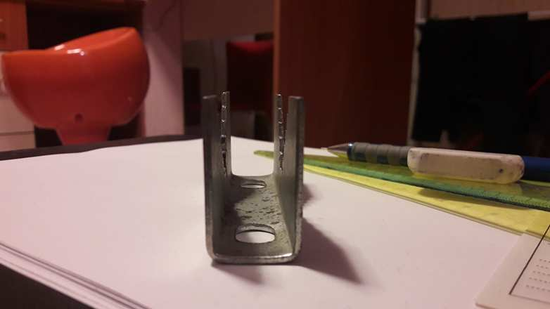
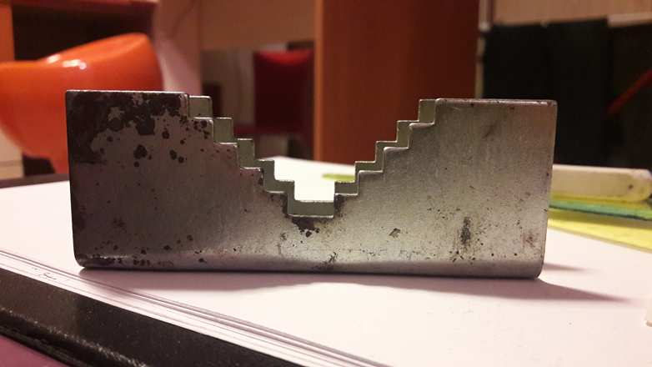
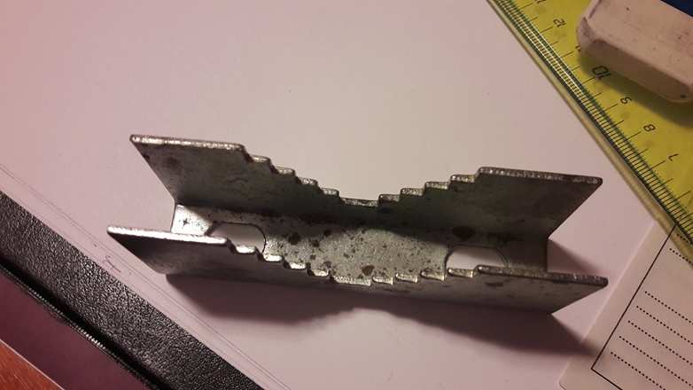
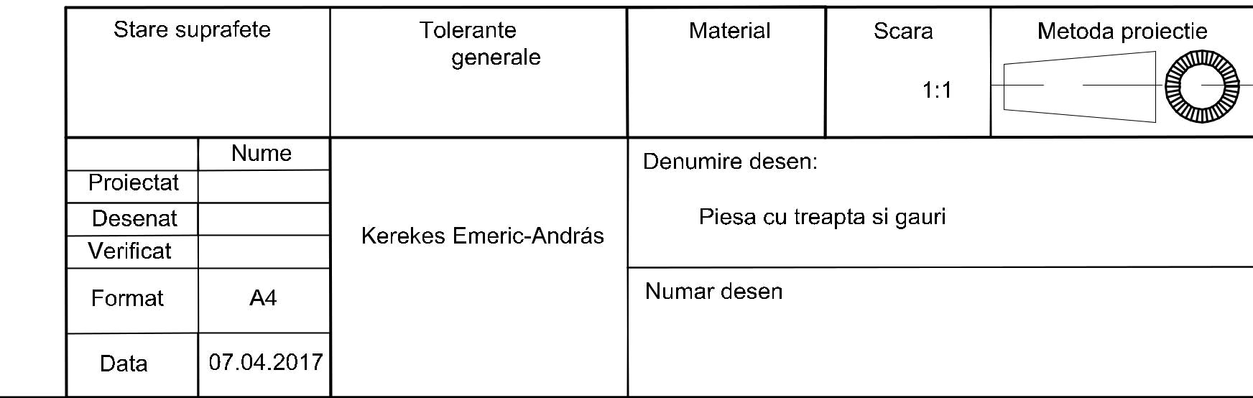
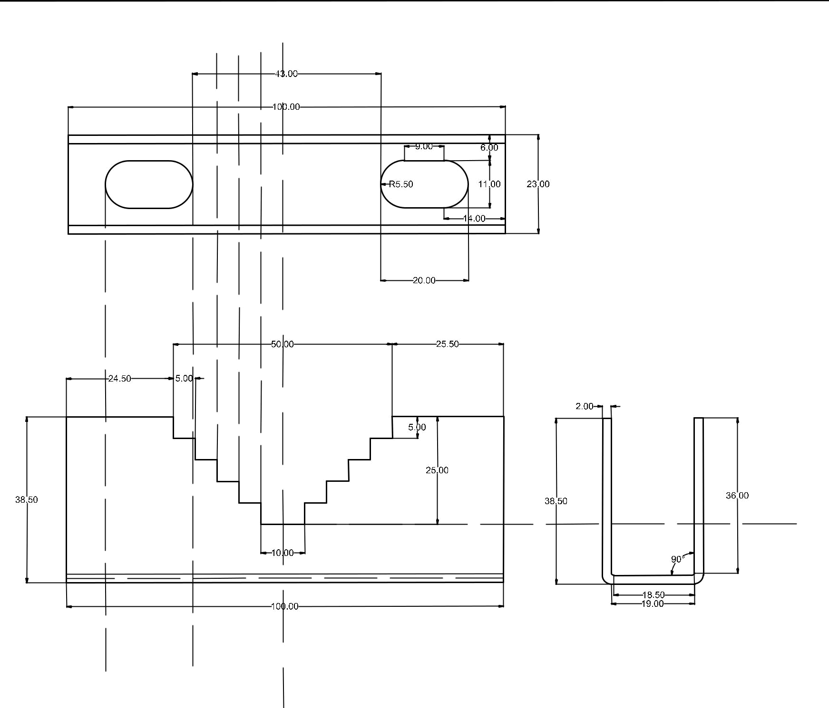

CAD 1

Drafting 2
Documentation: Pig Launchers/Pig Receivers
Pig launchers and receivers are commonly used in upstream oil and gas industry for periodic cleaning of pipelines carrying crude oil, natural gas and water from oil wells. A pig is a bullet shaped object which fits the pipeline from inside. The pig launcher launches the pig into pipeline and the upstream pressure pushes the pig to other end of the pipeline where it is received by the pig launcher. Hence generally arrangement for pig launchers and receivers are essentially the same, except for the difference between ‘Kicker line’ position for launchers and receivers. The sample drawing presents this general arrangement common to pig launchers and receivers.
- Proper equipment symbol for pig launcher (vertical or horizontal) should be selected first of all, as shown in the presented drawing. This should be selected from the list of equipment symbols on the legend sheets of a particular project.
- The major and minor barrels of the pig trap should be indicated as shown in the sample drawing. Minor barrel size is equal to pipeline size and the major barrel size is slightly larger.
- All the nozzles on the pig launcher should then be correctly represented with size and flanges. This includes door on the launcher, pig outlet to pipeline, kicker line, balancing line, PSV connection, purge, vent, drain and instrument nozzles, as shown in the sample drawing presented here. Typical instrumentation on the pig launcher would be pressure gauges and transmitters and pig indicators to know if the pig has been launched (or arrived in the case of pig receivers).
- Different lines connected to the pig launcher are the next to be drawn up. Line number, material class, size etc. is to be correctly assigned to each of the lines.
- Kicker line is used to pressurize the upstream side of pig so it can be launched. In case of receiver, kicker line provides an outlet for fluids arriving in the pig trap. Normally when pigging is not being performed, kicker line is closed using normally closed valve.
- Balancing line connecting the kicker line to minor barrel of the pig launcher, helps lower the pressure differential so that sudden shooting of the pig will not damage downstream automatic valves.
- A bypass line of the pig launcher is the normal route for the fluids when pigging is not taking place. This section upstream to the shutdown valve at beginning of pipeline can be protected against overpressure as indicated in the sample drawing.
- The hand operated valve (HV) on the bypass line is used to create a pressure differential for launching the pig (also for receiving the pig). A pressure differential indicator (PDI) has to be available to the HV operator to monitor the pressure differential.
- On the outlet of the pig launcher, another hand operated automatic valve is provided to open up the launcher upon pressurization.
- The pig launcher (and receiver) are also protected against overpressure with a PSV which discharges to flare. Typical representation of PSVs can be referred to in another article.
- Isolation valves, spectacle blinds, spacers etc. to be used for maintenance should be drawn up next, on various lines to and from the pig trap. The spectacle blinds, spacers etc. are usually connected right next to the isolation valves and equipment nozzles, as indicated in the sample drawing presented here.
- Drains should be provided either on major or minor barrel or on both for complete draining of the pig trap after the pig is launched or received. Sample drawing has indicated drains on both the barrels. These drains are connected to the closed drain system.
- Vents to flare and to atmosphere are required on pig launchers. Venting to flare for depressurization of the pig launcher can be achieved using bypass on the relief valve. For maintenance, when pig is not in operation it can be vented to atmosphere.
- A utility connection is required to purge the pig launcher / receiver after the pigging is done and the pig trap is depressurized and drained. A nitrogen connection should normally be provided as indicated in the sample drawing.
- Most of the guidelines mentioned for pig launchers also hold good for pig receivers.
- All the guidelines given here are very general and may be modified as per specific requirements of any particular project.

Reference link: https://texvyn.wordpress.com/category/uncategorized/page/2/

CAD 2

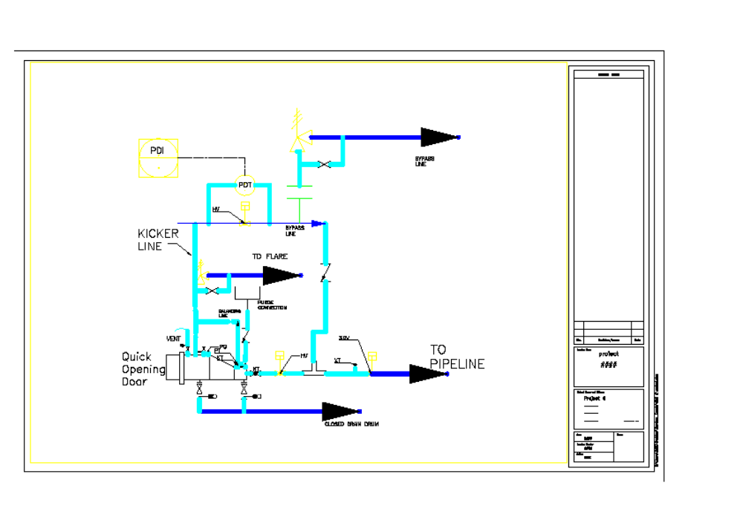

OpenGL
Bibliography used: <GL/gl.h>, <GL/glut.h>, <windows.h>
The objective of the proiect was to recreate the P&ID drawing using OpenGl language.

#include <windows.h> // for MS Windows
#include <GL/glut.h> // GLUT, include glu.h and gl.h
#include <GL/gl.h>
/* Global variables */

char title[] = "2D Pig launcher";
GLfloat pigx=0.0f;
int refreshMills = 15; // refresh interval in milliseconds [NEW]
/* Initialize OpenGL Graphics */
void initGL() {
glClearColor(0.0f, 0.0f, 0.0f, 1.0f); // Set background color to black and opaque
glClearDepth(1.0f); // Set background depth to farthest
glEnable(GL_DEPTH_TEST); // Enable depth testing for z-culling
glDepthFunc(GL_LEQUAL); // Set the type of depth-test
glShadeModel(GL_SMOOTH); // Enable smooth shading
glHint(GL_PERSPECTIVE_CORRECTION_HINT, GL_NICEST); // Nice perspective corrections

}
/* Handler for window-repaint event. Called back when the window first appears
and
whenever the window needs to be re-painted. */

void disp(){
glClear(GL_COLOR_BUFFER_BIT | GL_DEPTH_BUFFER_BIT); // Clear color and depth buffers
glMatrixMode(GL_MODELVIEW); // To operate on model-view matrix
// Render a color-cube consisting of 6 quads with different colors
glLoadIdentity(); // Reset the model-view matrix
glTranslatef(1.5f, 0.0f, -7.0f); // Move right and into the screen

glBegin(GL_POLYGON); //Begin drawing the bottom tube
glColor3f(1.0f, 1.0f, 0.0f); //yellow
glVertex3f(4.0f, -0.5f, 0.0f);
glVertex3f(-6.0f, -0.5f, 0.0f);
glVertex3f(-6.0f, -1.5f, 0.0f);
glVertex3f(4.0f, -1.5f, 0.0f);
glEnd(); // End of drawing bottom tube

glBegin(GL_POLYGON); // drawing the mud
glColor3f(1.10f, 0.6f, 0.5f);
glVertex3f(3.0f, -0.5f, 0.0f);
glVertex3f(1.0f, -0.5f, 0.0f);
glVertex3f(1.0f, -1.5f, 0.0f);
glVertex3f(3.0f, -1.5f, 0.0f);
glEnd(); //end mud

glBegin(GL_POLYGON); // oil/gas
glColor3f(1.0f, 1.0f, 0.0f);
if (pigx>1.1f)
glColor3f(0.0f, 0.0f, 1.0f);
glVertex3f(-5.0f, -0.5f, 0.0f);
glVertex3f(-4.7f, -0.5f, 0.0f);
glVertex3f(-4.7f, 0.5f, 0.0f);
glVertex3f(-5.0f, 0.5f, 0.0f);
glEnd(); // end oil/gas

glBegin(GL_POLYGON); // top tube
glColor3f(0.0f, 0.0f, 1.0f);
glVertex3f(-6.0f, 0.5f, 0.0f);
glVertex3f(2.0f, 0.5f, 0.0f);
glVertex3f(2.0f, 1.5f, 0.0f);
glVertex3f(-6.0f, 1.5f, 0.0f);
glEnd(); // end top tube

glBegin(GL_POLYGON); // connecting tube

glColor3f(1.0f, 1.0f, 1.0f);
glVertex3f(2.0f, 0.5f, 0.0f);
glVertex3f(1.0f, 0.5f, 0.0f);
glVertex3f(1.0f, -0.5f, 0.0f);
glVertex3f(2.0f, -0.5f, 0.0f);

glEnd(); // end of connecting tube

glBegin(GL_POLYGON); //connecting slim tube

glColor3f(0.0f, 0.0f, 1.0f);
glVertex3f(-6.0f, -0.5f, 0.0f);
glVertex3f(-6.0f, -1.5f, 0.0f);
glVertex3f(-5.9+pigx, -1.5f, 0.0f);
glVertex3f(-5.9+pigx, -0.5f, 0.0f);

glEnd(); // end of conecting tube

glTranslatef(pigx, 0.0, 0.0); //mooving the pig in the tube
glBegin(GL_POLYGON); // pig
glColor3f(1.0f, 0.0f, 0.0f);
glVertex3f(-6.0f, -0.5f, 0.0f);
glVertex3f(-5.0f, -0.5f, 0.0f);
glVertex3f(-4.5f, -1.0f, 0.0f);
glVertex3f(-5.0f, -1.5f, 0.0f);
glVertex3f(-6.0f, -1.5f, 0.0f);

glEnd(); //end of pig
glutSwapBuffers(); // Swap the front and back frame buffers (double buffering)

// Update the x-coordinate of the pig after each refresh [NEW]
pigx += 0.025f;
}
/* Called back when timer expired [NEW] */
void timer(int value) {
glutPostRedisplay(); // Post re-paint request to activate display()
glutTimerFunc(refreshMills, timer, 0); // next timer call milliseconds later
}
/* Handler for window re-size event. Called back when the window first appears
and
whenever the window is re-sized with its new width and height */
void reshape(GLsizei width, GLsizei height) { // GLsizei for non-negative integer
// Compute aspect ratio of the new window
if (height == 0) height = 1; // To prevent divide by 0
GLfloat aspect = (GLfloat)width / (GLfloat)height;
// Set the viewport to cover the new window
glViewport(0, 0, width, height);
// Set the viewport to cover the new window
glMatrixMode(GL_PROJECTION); // To operate on the Projection matrix
glLoadIdentity(); // Reset
// Enable perspective projection with fovy, aspect, zNear and zFar
gluPerspective(45.0f, aspect, 0.1f, 100.0f);
}
/* Main function: GLUT runs as a console application starting at main() */
int main(int argc, char** argv)
{
glutInit(&argc, argv); // Initialize GLUT
glutInitDisplayMode(GLUT_DOUBLE); // Enable double buffered mode
glutInitWindowSize(640, 480); // Set the window's initial width & height
glutInitWindowPosition(50, 50); // Position the window's initial top-left corner
glutCreateWindow(title); // Create window with the given title
glutDisplayFunc(disp); // Register callback handler for window re-paint event
glutReshapeFunc(reshape); // Register callback handler for window re-size event
initGL(); // Our own OpenGL initialization
glutTimerFunc(0, timer, 0); // First timer call immediately [NEW]
glutMainLoop(); // Enter the infinite event-processing loop
return 0;
}
INITIAL PHASE
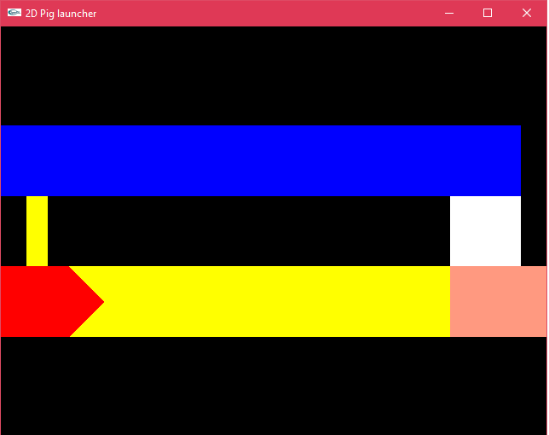

FINAL PHASE
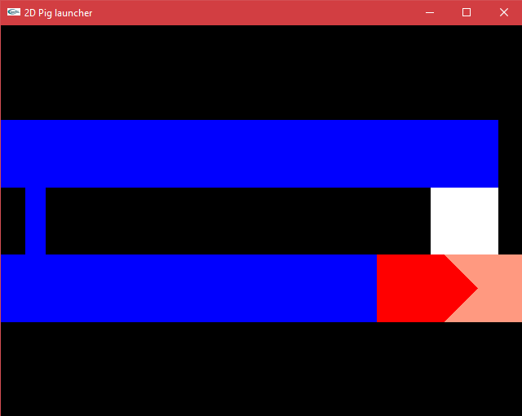

OpenGl

LISP
The program modifies the actual entities:
- Uppercase for the text
- Connetcts the circle centers with a lines

;; Converts all texts in the drawing to uppercase.
(defun C:Proiect (/ OR_OPEN OR_CLOSE filter ss tent telem tcontent telemupper n)

; retrieve the selection set containing both
; single and multiline text objects
(setq OR_OPEN '(-4 . "<OR") ; this could be useful in larger
OR_CLOSE '(-4 . "OR>") ; applications
filter (list OR_OPEN '(0 . "TEXT") '(0 . "MTEXT") OR_CLOSE)
ss (ssget "X" filter)
)
;select the circles
(setq cc (ssget "X" '((0 . "CIRCLE")) ))
;select the circles and texts
(setq all (list OR_OPEN '(0 . "TEXT") '(0 . "CIRCLE") '(0 . "LINE"))
l (ssget "X" all)
)

; iterate over the selection set
(setq n 0)
(repeat (sslength ss)
(setq
; retrieve the text entity from the ss
tent (entget (ssname ss n))
; retrieve the text group
telem (assoc 1 tent)
; the actual text content is the cdr
tcontent (cdr telem)
; make the content uppercase
tcontent (strcase tcontent)
; construct the new (dotted pair) element
telemupper (cons 1 tcontent)
; change the entity
tent (subst telemupper telem tent)
)
(entmod tent) ; update the entity definition
(setq n (1+ n)) ; next
)

;connects all centers with lines
(setq m 0)
(repeat (sslength cc)
(setq
cent1 (entget (ssname cc m))
cent2 (entget (ssname cc (1+ m)))
celem1 (assoc 10 cent1)
celem2 (assoc 10 cent2)
fp(cdr celem1)
sp(cdr celem2)
)
(command "line" fp sp "")
(setq m (1+ m))
)
;should resize all the entities except the polilines with 2 (it doesn`t work)
(setq k 0)
(repeat (sslength l)
(setq
kent (entget (ssname l k))
kelem (assoc 40 kent)
kontent (cdr kelem)
kops (cons 40 kontent)
kent (subst kontent kelem kent)
)
(entmod kent)
(setq k (1+ k))
)
(princ)
)

BEFORE
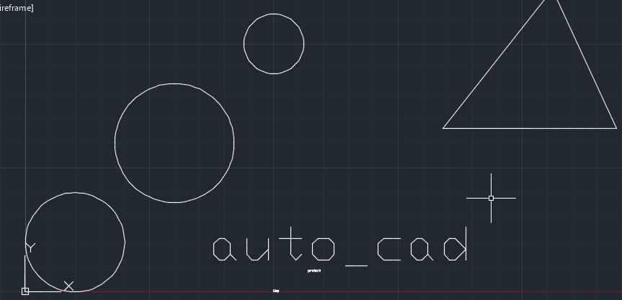

AFTER

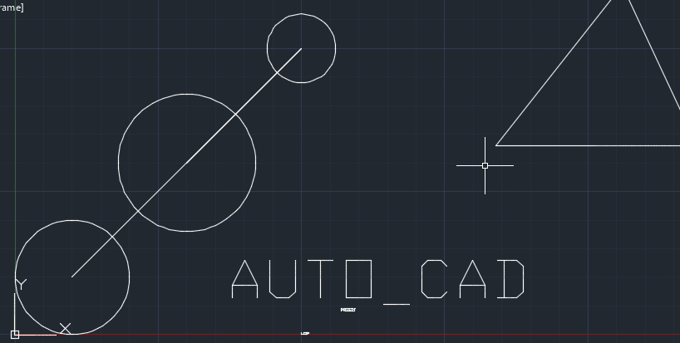

OpenGl

